**Type I and type II errors**

Earlier, you learned that you can use a hypothesis test to help determine if your results are statistically significant, or if they occurred by chance. However, because hypothesis testing is based on probability, there’s always a chance of drawing the wrong conclusion about the null hypothesis. In hypothesis testing, there are two types of errors you can make when drawing a conclusion: a Type I error and a Type II error.

In this reading, we’ll discuss the difference between Type I and Type II errors, and the risks involved in making each error.

**Errors in statistical decision-making**

Let’s review the steps for conducting a hypothesis test:

1. State the null hypothesis and the alternative hypothesis.
2. Choose a significance level.
3. Find the p-value.
4. Reject or fail to reject the null hypothesis.

When you decide to reject or fail to reject the null hypothesis, there are four possible outcomes–two represent correct choices, and two represent errors. You can:

* Reject the null hypothesis when it’s actually true (**Type I error)**
* Reject the null hypothesis when it’s actually false (Correct)
* Fail to reject the null hypothesis when it’s actually true (Correct)
* Fail to reject the null hypothesis when it’s actually false (**Type II error**)

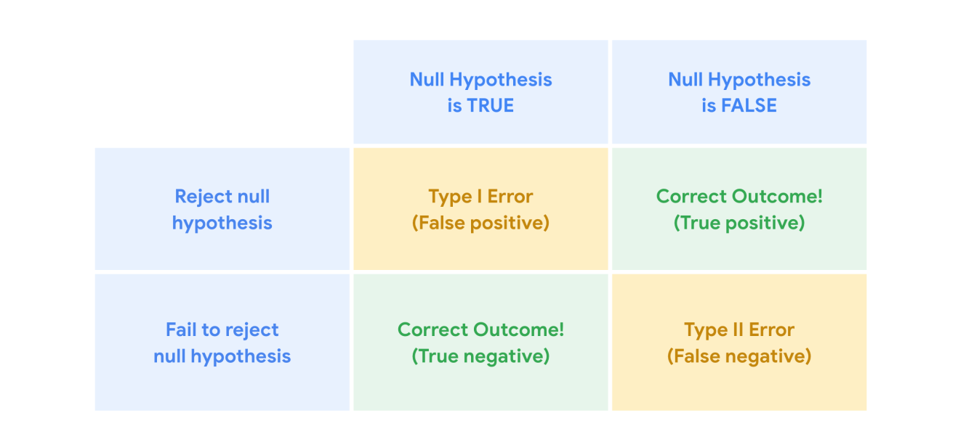

**Example: Clinical trial**

Let’s explore an example to get a better understanding of Type I and Type II errors. Hypothesis tests are often used in clinical trials to determine whether a new medicine leads to better outcomes in patients. Imagine you’re a data professional who works for a pharmaceutical company. The company invents a new medicine to treat the common cold. The company tests a random sample of 200 people with cold symptoms. Without medicine, the typical person experiences cold symptoms for 7.5 days. The average recovery time for people who take the medicine is 6.2 days.

You conduct a hypothesis test to determine if the effect of the medicine on recovery time is statistically significant, or due to chance.

In this case:

* Your **null hypothesis** (H0) is that the medicine has no effect.
* Your **alternative hypothesis** (Ha) is that the medicine is effective.

**Type I error**

A **Type 1 error**, also known as a false positive, occurs when you reject a null hypothesis that is actually true. In other words, you conclude that your result is statistically significant when in fact it occurred by chance.

For example, in your clinical trial, if the null hypothesis is true, that means the medicine has no effect. If you make a Type I error and reject the null hypothesis, you incorrectly conclude that the medicine relieves cold symptoms when it’s actually ineffective.

The probability of making a Type I error is called alpha (α). Your significance level, or alpha (α), represents the probability of making a Type I error. Typically, the significance level is set at 0.05, or 5%. A significance level of 5% means you are willing to accept a 5% chance you are wrong when you reject the null hypothesis.

**Reduce your risk**

To reduce your chance of making a Type I error, choose a lower significance level.

For instance, if you want to minimize the risk of a Type I error, you can choose a significance level of 1% instead of the standard 5%. This change reduces the chance of making a Type I error from 5% to 1%.

| **Significance level (α)** | **Chance of making Type I error** |
| --- | --- |
| 0.05 | 5% |
| 0.01 | 1% |

**Type II error**

However, reducing your risk of making a Type I error means you are more likely to make a Type II error, or false negative. A **Type II error** occurs when you fail to reject a null hypothesis which is actually false. In other words, you conclude your result occurred by chance, when in fact it didn’t.

For example, in your clinical study, if the null hypothesis is false, this means that the medicine is effective. If you make a Type II error and fail to reject the null hypothesis, you incorrectly conclude that the medicine is ineffective when it actually relieves cold symptoms.

The probability of making a Type II error is called beta (β), and beta is related to the power of a hypothesis test (power = 1- β). Power refers to the likelihood that a test can correctly detect a real effect when there is one.

**Reduce your risk**

You can reduce your risk of making a Type II error by ensuring your test has enough power. In data work, power is usually set at 0.80 or 80%. The higher the statistical power, the lower the probability of making a Type II error. To increase power, you can increase your sample size or your significance level.

**Note**: A detailed discussion of the concept of statistical power is beyond the scope of this course. Power is something you’ll learn more about as you advance in your career as a data professional and grow your knowledge of statistics.

**Potential risks of Type I and Type II errors**

As a data professional, it’s important to be aware of the potential risks involved in making the two types or errors.

A Type I error means rejecting a null hypothesis which is actually true. In general, making a Type I error often leads to implementing changes that are unnecessary and ineffective, and which waste valuable time and resources.

For example, if you make a Type I error in your clinical trial, the new medicine will be considered effective even though it’s actually ineffective. Based on this incorrect conclusion, an ineffective medication may be prescribed to a large number of people. Plus, other treatment options may be rejected in favor of the new medicine.

A Type II error means failing to reject a null hypothesis which is actually false. In general, making a Type II error may result in missed opportunities for positive change and innovation. A lack of innovation can be costly for people and organizations.

For example, if you make a Type II error in your clinical trial, the new medicine will be considered ineffective even though it’s actually effective. This means that a useful medication may not reach a large number of people who could benefit from it.

**Key takeaways**

As a data professional, it helps to be aware of the potential errors built into hypothesis testing and how they can affect your results. Depending on the specific situation, you may choose to minimize the risk of either a Type I or Type II error. Ultimately, it’s your responsibility as a data professional to determine which type of error is riskier based on the goals of your analysis.

**Resources for more information**

To learn more about Type I and Type II errors, refer to the following resources:

* This [article from Simply Psychology](https://www.simplypsychology.org/type_I_and_type_II_errors.html) contains a helpful summary of the differences between Type I and Type II errors.